Lesson 1: Why is driving safer today than it was ten years ago, even though the number of vehicle collisions has gone up?

Previous Lesson | There is no previous lesson.
This Lesson  Anchoring Phenomenon  3 days   | 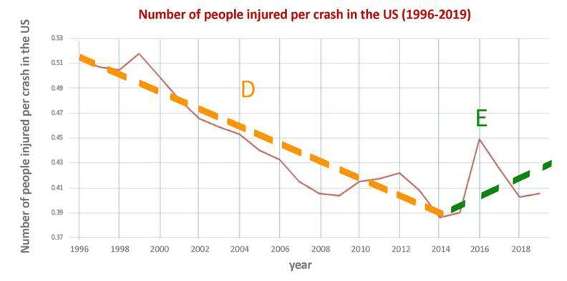 | We analyze graphs of vehicle deaths and injuries over time and determine that while deaths have decreased overall, we see a slight increase in injuries and vehicle collisions in recent years. We develop models to predict how distracted driving and vehicle factors and features might contribute to these trends. We ask questions about potential causes for trends we observed and develop ideas for investigations to help figure out the answers to our questions.
Next Lesson | We will analyze videos of two drivers encountering a sudden obstacle, one who is not distracted, and one who is distracted.

BUILDING TOWARD NGSS  HS-ETS1-3, HS-PS2-2, HS-PS2-3, HS-PS2-1   | What students will do  1.A Ask questions that arise from careful analysis of data about correlations between vehicle collisions over time and changes within and outside of the vehicle-driver system such as driver distraction, vehicle mass, and vehicle velocity that can only be answered using empirical evidence. (SEP: 1.1; CCC 2.1; DCI: PS2.A)  1.B Develop a model of a vehicle-driver system that includes safety components designed to alter the physics of a collision in order to predict the impact these components have on traffic safety statistics. (SEP: 2.6; CCC 2.3; PS2.A)  What students will figure out  - While overall trends in deaths have decreased, in recent years the number of collisions and injuries has increased.  - There are many potential causes for these trends, including distracted driving and vehicle factors and features.  - We have many questions about how distracted driving might affect the outcomes of a collision, and the effects of different vehicle factors and features.

Lesson 1 • Learning Plan Snapshot
Part | Duration | Summary | Slide | Materials
1 | 4 min | SHARE INITIAL IDEAS ABOUT VEHICLE SAFETY  Preview crash statistics and consider what factors might affect safety. | A
2 | 12 min | MAKE PREDICTIONS ABOUT GRAPHS OF VEHICLE SAFETY OVER TIME  Introduce the first set of graphs and elicit initial noticings. Make predictions about driving safety over time, and brainstorm what might be causing those trends. Document ideas on chart paper. Discuss predictions, and how to measure safety. | B-D | “Things that make driving safer/Things that make driving less safe” chart
3 | 13 min | ANALYZE VEHICLE FATALITY STATISTICS  Orient to the vehicle fatality graphs. Facilitate a Building Understand Discussion to identify patterns in the graphs. Make predictions about crashes and injuries. | E-F | US Vehicle Fatalities
4 | 6 min | IDENTIFY AND RECORD TRENDS IN INJURIES AND COLLISIONS  Project data for crashes and injuries over the last 100 years over blank chart paper. Identify and label trend lines and important timepoints on the chart paper. | G | Crashes and Injuries, Blank chart paper posted on the projector screen to create the “Trend Lines” chart
5 | 6 min | BRAINSTORM POTENTIAL CAUSES OF THE TRENDS WE IDENTIFIED  Analyze individual trend lines and brainstorm potential causes for each trend line. Share potential causes for the trend lines with the class. | H-I | Crashes and Injuries, “Trend Lines” chart, whiteboards, markers
6 | 4 min | DEVELOP INITIAL CLAIMS  Develop initial claims about distracted driving and share claims with a partner. | J | “Trend Lines” chart

End of day 1
7 | 7 min | MODEL COLLISION SCENARIOS WITH A PARTNER  Use small strips of paper to model the collision of two vehicles in distracted and non-distracted driver scenarios. | K | 2 toy cars per partner pair, “Trend Lines” chart, Collision Scenario labels, 10 strips of paper
8 | 13 min | DEVELOP A DISTRACTED DRIVING CONSENSUS MODEL  Come to initial consensus on what might be different between a distracted and non-distracted driver collision that could contribute to the trends the class has identified and create a public record of these ideas. | L | Collision Scenario labels, 10 strips of paper, 3 premade charts for the Distracted Driving Consensus Model, markers
9 | 7 min | DEVELOP AN INITIAL MODEL FOR FACTORS AND FEATURES  Consider factors and features outside of human behavior that might have an effect on the outcome of a collision. Develop an individual model of a factor or feature. | O | Other Factors/Features
10 | 18 min | CONSTRUCT THE FACTORS AND FEATURES INITIAL CONSENSUS MODEL  Determine what factors might affect the outcome of a collision and when those factors work. | P | Other Factors/Features, Chart paper, markers

End of day 2
11 | 3 min | REVISIT MODEL AND WRITE DQB QUESTIONS  Review the model constructed at the end of last class and compare this model to individual models. | Q-R | Other Factors/Features, sticky notes, markers, Factors and Features Initial Consensus Model, Distracted Driving Initial Consensus Model
12 | 16 min | Add questions to the DQB  Add questions in question clusters to the DQB. | S | Sticky notes, markers, Factors and Features Initial Consensus Model, Distracted Driving Initial Consensus Model
13 | 10 min | BRAINSTORM RELATED PHENOMENA  Consider other collisions in which we want to prevent damage. Add these ideas to a Related Phenomena chart. | T | Chart paper, markers
14 | 16 min | DEVELOP IDEAS FOR INVESTIGATION AND DATA WE MIGHT NEED  Refocus the class on the importance of exploring ideas in both initial consensus models, and develop ideas for investigation related to both models. | U-V | Strips of 8.5x11 paper, tape, markers, Trend lines chart, Ideas for Investigations and Data We Might Need chart

End of day 3

Lesson 1 • Materials List
 | per student | per group | per class
Lesson materials | - Other Factors/Features  - sticky notes  - markers  - Sticky notes  - Strips of 8.5x11 paper  - tape | - US Vehicle Fatalities  - Crashes and Injuries  - 2 toy cars per partner pair | - “Things that make driving safer/Things that make driving less safe” chart  - Blank chart paper posted on the projector screen to create the “Trend Lines” chart  - “Trend Lines” chart  - whiteboards  - markers  - Collision Scenario labels  - 10 strips of paper  - 3 premade charts for the Distracted Driving Consensus Model  - Distracted Driving Initial Consensus Model charts  - Factors charts  - Chart paper  - Factors and Features Initial Consensus Model  - Distracted Driving Initial Consensus Model  - Trend lines chart  - Ideas for Investigations and Data We Might Need chart

Materials preparation (30 minutes)

Review teacher guide, slides, and teacher references or keys (if applicable).

Make copies of handouts and ensure sufficient copies of student references, readings, and procedures are available.

For Day 1:
- Before class prepare a chart paper with the title: Things that make driving safer/Things that make driving less safe.
- View the dataset located on slide G. This dataset will be marked up as a class. Access to this marked-up version will be needed throughout the unit. Determine how you will save a record of student ideas around this graph in the future. Some options are to recreate the graphs on a separate piece of chart paper for each class period or to create a digital version that can easily be revisited using Google draw or another platform for each class period.

For Day 2:
- Have 2 toy cars per partner pair ready to distribute.
- Using 4 regular pieces of printer or construction paper, create a total of 4 scenario labels:
- Case 1: Perpendicular collision (or T-bone)
- Case 2: Side against side collisions
- Case 3: Head-on collision
- Case 4: Rear-end collision
- Create 3 charts for the Distracted Driving Initial Consensus Model. The charts should be labeled with the following headers:
- Chart 1 at the top of the chart- What is happening in all these cases BEFORE the collisions that would help explain these different outcomes
- Halfway down the chart, add a second header- What is happening AT the point in time at which first contact is made in the collision to CAUSE the different outcomes
- Chart 2- Outcome for a Collision for Distracted vs. Non Distracted Driving
- Chart 3- How would the outcome for the people in both vehicles compare?

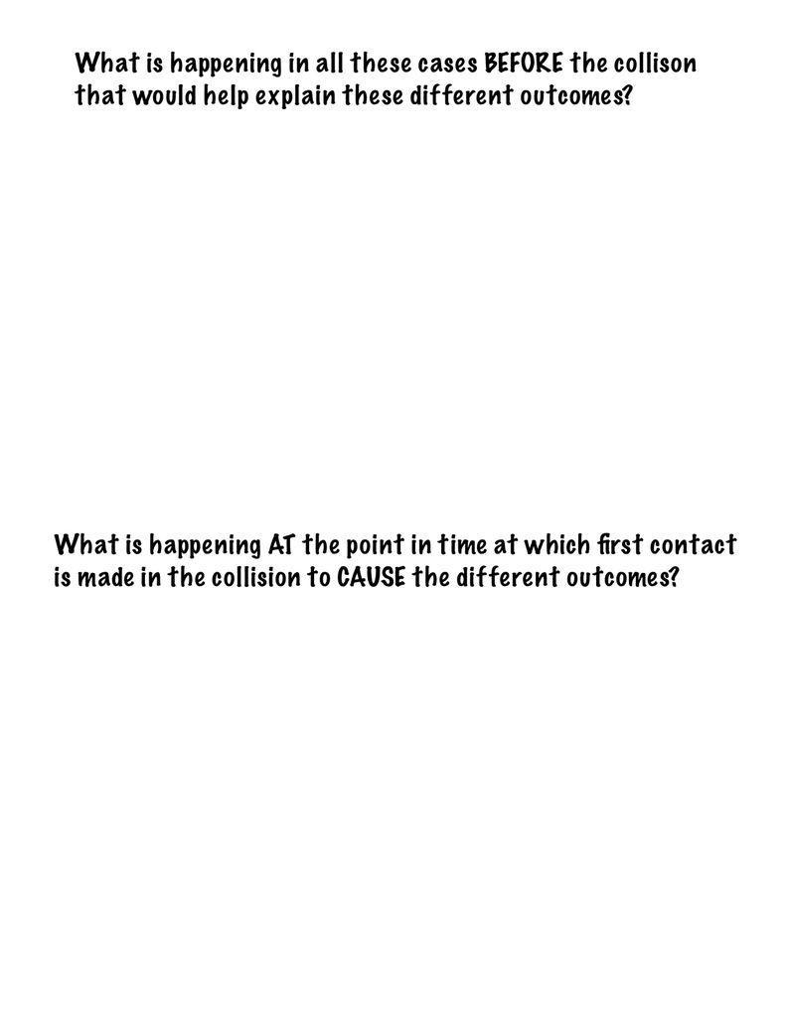 | 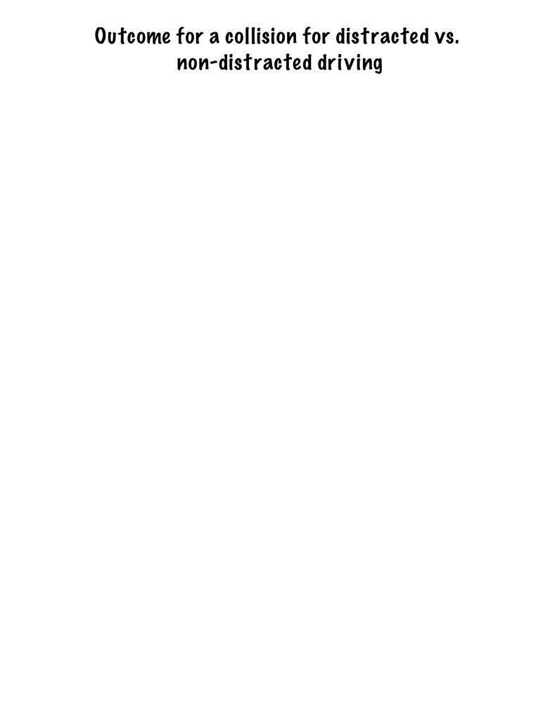 | 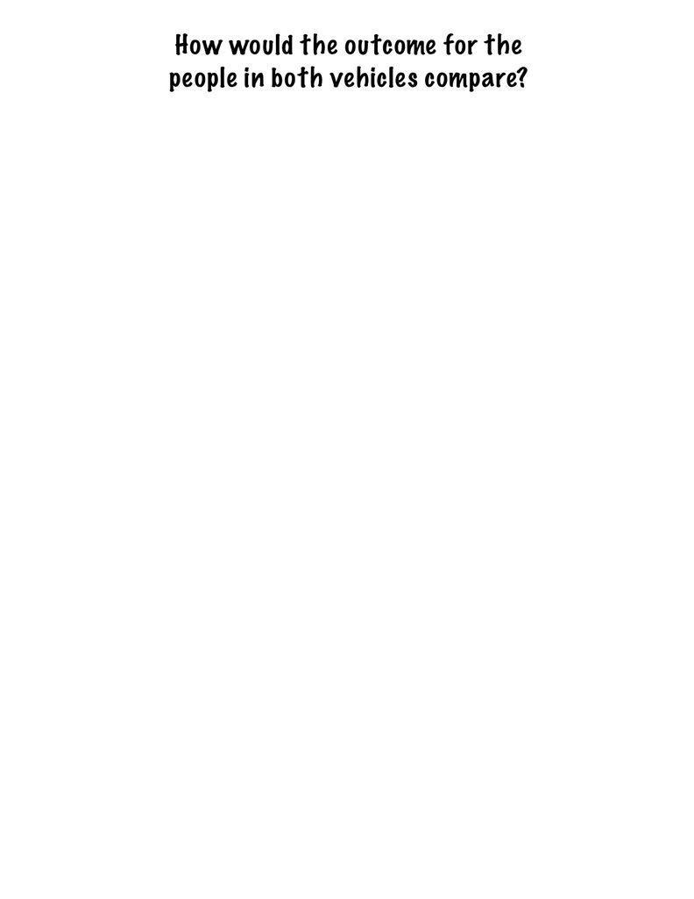
- At the end of Day 2 take a high resolution photograph of the Distracted Driving Initial Consensus Model. Be prepared to share the image with students at the end of the day.

For Day 3:
- Gather 20 pieces of printer or construction paper per class. Cut up paper into roughly 4 slips per page. Students will use these strips of paper to write down their ideas for investigation and tape these slips of paper to the DQB next to related DQB questions.
- Replace the tend line picture with your two marked-up trend line graphs to slide V before class.

Lesson 1 • Where We Are Going and NOT Going

Where We Are Going

In this lesson, students will analyze data on motor vehicle collisions, injuries, and deaths over time, and identify trends in the data. Students will consider some of the potential causes for the trends and develop questions that require empirical evidence to answer. They begin to think about how the design of a vehicle might impact the outcome of a collision, and what can be done to improve those outcomes. They also begin to consider the impact of being distracted on the probability of being in a collision.

Because this is the very first lesson in a new unit, the goal of this lesson is not to establish any ideas associated with the relevant DCI (PS2.A), but rather to get student ideas on the table related to that DCI. Because of this, we do not specify which element of this DCI is being addressed. Students will have ideas about vehicle collisions, distracted driving, etc. Some students may bring in ideas about forces, and momentum. Accept all these ideas without judgment right now, even if they are scientifically inaccurate. If a student puts an idea on the table that feels very inaccurate, you can respond with one of the following:
- “Wow, that's an interesting idea! Does anybody disagree?”
- “Let’s follow up on that for sure. How could we investigate the claim _____ made?” Let’s add that to our ideas for investigations later.”
- “What an interesting idea. Could you reframe that as a question for our DQB?”

In Lesson 1, and throughout this unit, students are encouraged to consider how humans and non-humans outside the vehicle might be impacted by decision-making related to vehicle safety. Encourage students to think about not just the safety of the driver and passengers, but the safety of pedestrians, trees, and animals. Students might also think more broadly about safety, considering the impact of larger vehicles on emissions, for example, and the resulting impact on the natural world.

Where We Are NOT Going

While trends vary by age, racial identity, socioeconomic status, and location, we have chosen to present data representative of the entire USA in Lesson 1. As students progress through the unit, new science ideas will lead students to consider how existing disparities might affect these statistics. In Lesson Set 2, students will figure out that the safety features they have identified are not accessible to all drivers and passengers, and consider the impact of policy on the statistics they saw in Lesson 1.

LEARNING PLAN for LESSON 1
1 · SHARE INITIAL IDEAS ABOUT VEHICLE SAFETY | 4 min
MATERIALS: None
ADDITIONAL GUIDANCE Supporting empathy and emotions: Be aware that this unit is based on trends in vehicle collisions. Before beginning this unit, make sure to reach out to the counselor at your school for student-specific support and strategies that might be needed in regards to the students in your classroom, and consider asking the counselor to join you on the first day of instruction. Also consider planning follow-up check-ins with the counselor in regards to any students who may need additional emotional support. Reach out to students’ support system at home before the unit using Pre-Unit Letter Home. This letter is a way to communicate with trusted adults and make them aware of the content of the unit. The letter also provides an opportunity for trusted adults to share important context with you about students’ experiences and background that might be relevant. This topic can be sensitive for those who have experienced injury, trauma or loss due to collisions. Please be mindful of this and provide safety and support by sharing awareness. If there is time, consider beginning the class with a brief mindfulness activity (see Trauma-Informed SEL Supports for suggestions) Consider beginning the unit by saying: As we work through this unit, be mindful of any impact that you are noticing within yourself based on your own personal experiences. If you need to talk, process, or regain some grounding in the here and now, please let me or the school counselor know. Be aware that students who are struggling may demonstrate a variety of behaviors including but not limited to: fidgeting, withdrawal, disruption or distraction, rapid breathing, holding their breath, change in body language or tonation. If you notice a student might be struggling, share what you are observing and ask if they need some help.  Preview a traffic crash statistic. Display slide A. Read the statistic on the top of the slide.  - Road traffic crashes are a leading cause of death in the United States for people aged 1–54.  Share initial ideas. Cue students to reflect for one minute on the three questions on the slide. Give students roughly one minute to turn and talk to a partner about their ideas.  - What makes driving so dangerous?  - What factors affect vehicle safety?  - Whose safety are we considering when we talk about vehicle safety? Who or what else should we take into account?  Ask students to share their ideas with the class.✱ Example prompts and responses are below, but be sure to accept and validate all serious ideas at this stage, without spending more than a minute or two here.  Suggested prompt Sample student response  What do we think makes driving so dangerous? Maybe how fast cars go now. Yeah, sometimes cars are jacked up or modified. Maybe because they are so big now they are more dangerous or deadly? Sometimes people are distracted, which isn’t good if you’re driving.  So what factors do you all think affects driving safety? Speed If the driver is paying attention.  Who or what else should we take into account? The passengers could be impacted. Maybe the other people on the road or the sides of the road. People in other cars if there is a collision between two cars. Maybe trees on the sidewalk, or animals who cross the road. | ✱ ATTENDING TO EQUITY  Universal Design for Learning: Allowing students to express their ideas using multiple modalities supports student ownership of their learning by giving students choice, access, and control in navigating their own understanding around the science ideas. Consider agreeing on a set of non-verbal signals to use as a class (e.g. head nods, thumbs up, ASL signs) for signaling non-verbal agreement, disagreement, and wondering/questioning as a way to ensure equitable participation by giving students additional modalities with which to express themselves.

2 · MAKE PREDICTIONS ABOUT GRAPHS OF VEHICLE SAFETY OVER TIME | 12 min
MATERIALS: “Things that make driving safer/Things that make driving less safe” chart
Introduce the first set of graphs and elicit initial noticings. Display slide B. Say, These graphs show us some statistics about the number of people and vehicles in the U.S. over the last hundred years. Give students a moment to read the graphs on the slide. Ask students to share what they notice about the graphs.  Students may share the following ideas:  - The number of people has almost tripled over the last 100 years.  - The number of vehicles is many times greater (over 30 times greater) now than it was over 100 years ago.  - The ratio of people per vehicle has dropped a lot. A hundred years ago, vehicles were pretty rare in comparison to people, but now there is almost one vehicle for every person.  Make predictions about safety trends. Display slide C. Say, After looking at those graphs, do we think driving has gotten safer over time or less safe? Why? And for whom?  Allow students to read the questions on the slide, or read them aloud:  - Do we think driving has gotten safer over time, or less safe? Why?  - For which people/places/things that we wanted to take into account?  Give students time to discuss these questions with a partner, then have students share out their ideas with the class. Students may share that they think driving has gotten safer, or potentially less safe over time, and that this may apply to everyone or thing identified on the last slide.  Ask students, If we think driving has gotten safer or less safe over time, what things would be making driving safer or less safe?  Document initial ideas.✱ Display the chart paper titled “Things that make driving safer/Things that make driving less safe.” Ask students to share their ideas with the class.✱ Record ideas as they are shared on the chart. For each factor brought up, ask for a show of hands of who else had a similar idea. For each factor that had multiple students considering it, point out that it is interesting that they all shared a similar idea, but don’t take time to write down each factor or a tally at this point.  Students may mention the following for things that make driving safer, or less safe:  - Some people drive too fast which is unsafe  - People may be more distracted or not paying attention recently which is unsafe.  - The number of cars has increased, so there may be more crashes and injuries.  - There are more people on the road now than there used to be, so the crowded roads may be less safe.  - We may have more people with learner's permits/provisional licenses and such than we did in the past.  - Sometimes it can be hard to see or the roads are hazardous, which can affect safety.  - Airbags, seatbelts, size of cars, type of car, other car factors may have made driving more safe.  After students have shared some factors, help students pull out the idea that “safer for whom” might include others beyond those in a vehicle. Ask students, Do these factors impact just the driver, or other people? Who else might these factors affect?  These could include things like:  - Passengers inside the car  - People outside the car (pedestrians, bicyclists, construction workers, other cars)  - the environment  - animals, plants, etc. that might be in the way of a car  Discuss predictions and how to measure safety. Say, We have been talking about safety, and what factors or things we might have to consider when thinking about safety. But, how exactly would we even measure safety?  Display slide D. Allow students a moment to consider the first question on the slide before sharing their ideas with the class, or have a student read it aloud:  - How could we quantify or measure safety?  Look for and highlight ideas about the number of people injured or killed in vehicle collisions.  Then have another student read the second prompt on the slide aloud:  - If your prediction about driving safety over time is true, what pattern would we expect to see in this measure of safety over the past 100 years?  Press students to make a connection here between a trend such as “injuries go up” and their predictions from earlier about if driving is more or less safe. Students should say that if driving is safer today than it has been in the past, then the number of injuries and/or deaths would go down over time. If driving is less safe today than it was in the past, then the number of injuries and/or deaths would go up over time. | ✱ STRATEGIES FOR THIS INITIAL IDEAS DISCUSSION  Be explicit with students about your role in this discussion. Your role is to elicit and record a diversity of ideas, right or wrong. Make space for all students to share their ideas (including experiences they have had outside school, in addition to ideas from science class). Encourage student-to-student talk with a focus on raising questions, clarifying, or adding onto what someone has said, rather than a focus on debating or arguing. Students might also use head nods or hand signals to show they had a similar idea.  ✱ ATTENDING TO EQUITY  Universal Design for Learning: In any Initial Ideas Discussion it is important to encourage students to draw from their own ideas and not worry about whether their ideas or questions are right or wrong. All ideas and questions are welcome. This provides students access by supporting student engagement.

3 · ANALYZE VEHICLE FATALITY STATISTICS | 13 min
MATERIALS: US Vehicle Fatalities
Orient to the vehicle fatality graphs. Say, Let’s look at a couple of these measures and see how they compare to our predictions. Distribute a handout US Vehicle Fatalities to each partner pair.  Give students a minute to orient to both graphs. Then, as a class, discuss what students notice, focusing first on what the differences are between what is being shown on each graph and what the y-axis tells us about the dataset. Look for students to notice the per unit comparison is different (per 100,000 people vs. per 100 million vehicle miles traveled). Explain what per million vehicle miles traveled means and why that measure might help control for the population increase we have seen in previous graphs, as well as more people having cars and people generally driving more over time.  Building Understandings Discussion. After looking at what the graphs show us, focus on the patterns in each graph. Present slide E and read the questions on the slide aloud:  - What patterns do we notice?  - How does this compare to our predictions?  Students may notice the following patterns:  - The number of deaths have generally been going down over time on both graphs.  - Deaths per 100,000 people went up from 1920 to the mid 1930s, but then the general trend after that period has been downward.  - Even though the “Deaths per 100,000 people '' graph fluctuates some, in general deaths have been going down over the last 90 years.  - The 100 million vehicle miles graph decreased quickly at first, but it has leveled out in more recent years (2000s).  Highlight an unclear trend over the past couple of decades. When students mention deaths going down, ask, What about over the past couple of decades, are deaths still going down? Accept all ideas and welcome disagreement, as the next slide will zoom in on the last 30 years.  ADDITIONAL GUIDANCE There are many observations that can be made about the two graphs on slide E. While students may want to point out every trend they see, limit this conversation to a few minutes. The class should move quickly here so that they can spend more time analyzing the graphs on slide G in just a moment, because they will carry forward into future lessons. The goal of the dataset on Slide E is to allow students to see a general trend that deaths are decreasing even though the population is increasing, and to wonder about if death rates have kept going down or leveled out. This noticing will navigate us into the next sets of graphs.  Say, Let’s zoom into the last part of the 2nd graph and stretch the scale a bit so we can see whether this is a trend that is decreasing in the last 30 years of the graph or if the death rate is relatively flat (constant).  Analyze data from the last 30 years. Display Graph F. Say, The pink box is the last part of the 2nd graph we were looking at on the last slide. The section we are zooming into is shown above it.  Ask students what they notice using the first prompt on the slide. Guide students to identify that this graph set also shows a decrease in deaths over time.  Make predictions about crashes and injuries. Using the second prompt on the slide, ask students whether they think we will see similar trends in the number of crashes and injuries over that same period, or if those graphs will look different. Accept all ideas. If there is time, invite 1-2 students to also share their reasoning.  Point out the different metrics we have used so far. Say, Let’s take a look at data on crashes and injuries. Before we do, notice that for fatalities we looked at two different ways to quantify fatalities, one was per 100,00 people and one was per million vehicle miles traveled. So, let’s think about what metrics were used for the next two graphs as well. | ✱ STRATEGIES FOR THIS BUILDING UNDERSTANDINGS DISCUSSION  Be explicit with students about your role in this discussion, and how it is different from the Initial Ideas Discussion. Your role is now to press students for evidence to ground our discussion in the data.  Tell students explicitly, “We aren’t sharing our initial ideas now, we are basing our ideas on evidence from a shared experience. My role in this discussion is to press for evidence, regardless of if the ideas are right or wrong. So you might hear me ask, “Where did you see that in the data?” Or to ask you to clarify the pattern by asking “Can you say more about what that pattern was that you saw?” That does not mean you are wrong! It is my job to push us as a class to articulate the evidence we have to support the patterns we noticed.

4 · IDENTIFY AND RECORD TRENDS IN INJURIES AND COLLISIONS | 6 min
MATERIALS: Crashes and Injuries, Blank chart paper posted on the projector screen to create the “Trend Lines” chart
Analyze Data. Present slide G. Distribute a handout of Crashes and Injuries to each partner pair. Give students a moment to turn and talk about the questions on the slide:  - What do we notice?  - How does this compare to our predictions?  - What do we wonder?  Begin a whole group share-out by asking about differences students notice between measurements used on each graph. Listen for students to say that the y-axis measure is different. The top graph shows the total number of crashes, while the bottom graph shows the number of people injured per crash.  Discuss the y-axis range for the second graph. Ask students what it means for there to be 0.5 people injured per crash. Listen for ideas about this being a ratio or a percentage, such as:  - 50 injuries per 100 crashes  - 50% of the people in a crash get injured  - 1 person injured every 2 crashes  Have 2-3 students share out how this data compares to the predictions they had made after viewing the last slide. As students share their predictions and how this graph either matches or does not match their predictions, ask them to point to what in the data had led them to that conclusion.  Identify trend lines individually. Point out that students seem to be referencing specific sections of the graphs, and that the graph shows several trends, as they have mentioned. Ask students to look at the data and draw any trend lines they see on Crashes and Injuries. Suggest that they use a different color to label each trend that they see.  Mark key trends lines on chart paper. After students have drawn trend lines on their own, ask students about what trends we see in these two different measures over time. Add the blank chart paper pieces under the projected image of the graph. As students share these trends, draw the trend line that is being identified on the dataset. Students should identify at least two trends in the first graph, and at least one trend in the second:  - Top graph:  - decrease in first part, (1996-2009)  - an uptick in the second part (2009 onward)  - (Optional) some leveling off in recent years (2016-2019)  - Bottom shows:  - decrease in first part, (1996-2009) and some fluctuation and leveling off (2009 onward) OR  - a general decrease over the entire period with some more fluctuation toward the end.  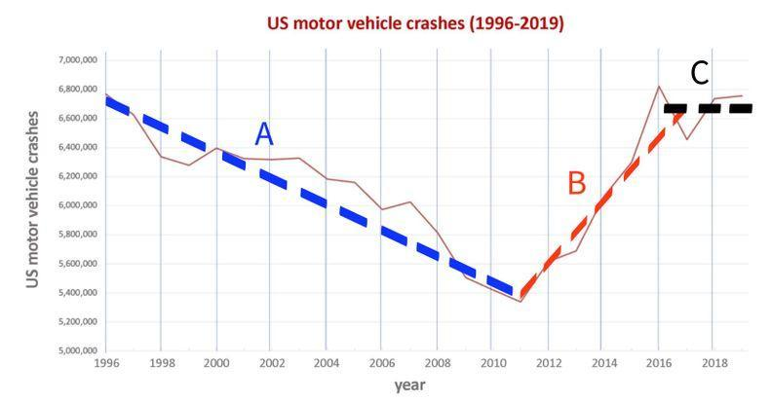   As students share, ask them to come up to the chart and draw the trend line that they have identified. For each new trend line, make sure to have the student use a new color. Use letters (A, B, C, etc…) to label each of the trend lines on each graph after students have identified a section. The example shown here shows each graph broken up into two to three possible trend lines each.  Identify and mark important timepoints on the chart paper. Have students identify the points where trends begin, end or change. Point out the years when these timepoints happen and mark or write the year in a larger size on the x-axis. This step will become more important later when considering the possible causes of each trend.  ADDITIONAL GUIDANCE As the class identifies trends, many students will be tempted to make inferences about what might be causing these trends. If this happens, validate students' ideas as interesting, but do not comment on their utility. Use these ideas to navigate to the next section by saying something like, Interesting. We are going to shift gears in just a moment and think about what might be going on here, so keep track of these ideas in your notebook for now. | ✱ ATTENDING TO EQUITY  Universal Design for Learning: Use representations like color coding and lettering. While color coding is a useful way to quickly reference the trends, letters helps ensure accessibility for any student who may be colorblind. If you know you have colorblind students, consider a color palette that uses orange, blue, black, or dark brown, as these tend to be more easily distinguished by people who are colorblind.

5 · BRAINSTORM POTENTIAL CAUSES OF THE TRENDS WE IDENTIFIED | 6 min
MATERIALS: Crashes and Injuries, “Trend Lines” chart, whiteboards, markers
Developing initial explanations. Show slide H. Review the directions on the slide and group students based on the number of trend lines you have identified as a class (e.g. 5 trend lines would mean groups of 5). Emphasize to students that the goal is for every group to have something that can be held up and be read by everyone in the room for each trend line. Distribute markers and whiteboards to each student.

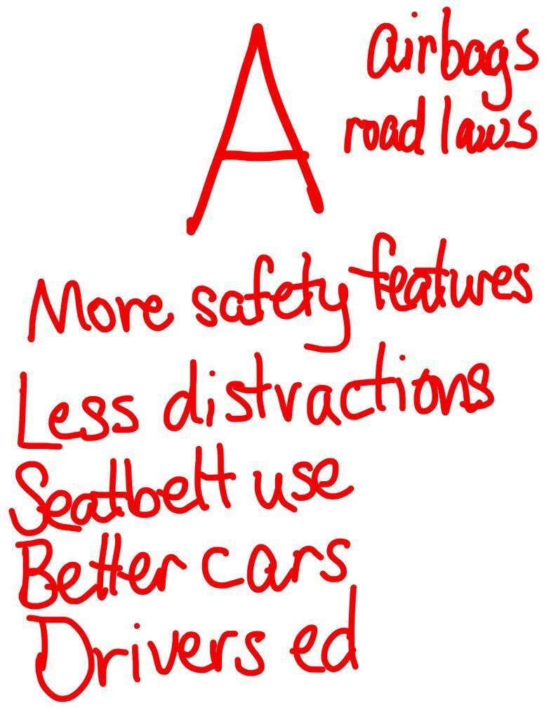
Ask groups to assign each group member a trend line amongst themselves. Give small groups 5 minutes to record their ideas. If students finish their trend line early, suggest that they help out their fellow group members with their assigned trend line.

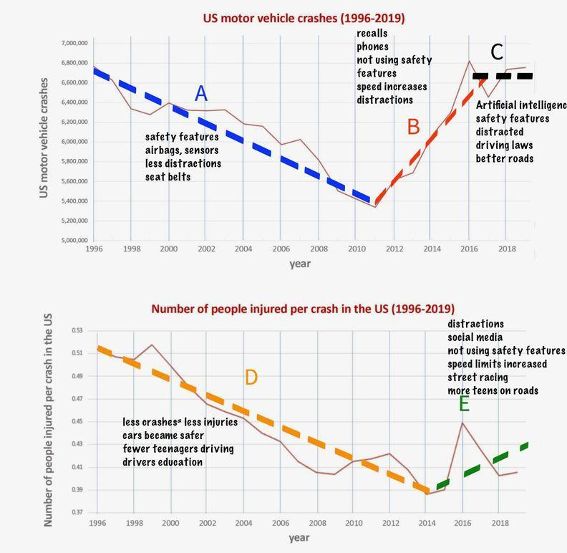
Share possible causes for trends with the class. Display slide I. Ask all students to turn their chairs towards the center of the room. Beginning with trend A, ask those who identified potential causes for trend A to hold up their possible cause list. Give the class a moment to read the charts and ask students to share out any potential causes that make sense to them, or are mentioned across multiple groups. As students are sharing out, write these causes around the part of the trend line that they are discussing. Give roughly 90 seconds for each trend.

Draw out ideas about distracted driving. As students share out, make sure that one possible cause that emerges across the trend lines of increased crashes and injuries is related to distracted driving. If it doesn’t come up naturally, you can ask students to consider changes in technology over the past few decades that might have led to this increase. If students don’t come up with cellphones or other distractions quickly, do not play guess-what’s-in-my-head. Say, I wonder if people are more distracted now than they were before. Could this have an impact on the data?

ADDITIONAL GUIDANCE | Supporting Empathy and Emotions: Some students in your class may have experienced trauma related to distracted driving. Make sure to be mindful of any changes such as body language adjustments, intonation, and distraction. If a student seems to exhibit any changes, consider asking that student privately and quietly if they would like to step out and see the counselor or take a moment to themselves for a break in the hallway or bathroom.

Tell students that we will develop some initial models about the role of each of these possible causes. Suggest that we start with distracted driving, because we all agree it could have an impact.

6 · DEVELOP INITIAL CLAIMS | 4 min
MATERIALS: “Trend Lines” chart
Develop Initial Claims. Display slide J. Give students 4 minutes to record an initial claim for each question. Have students compare these claims with their partner.

Poll students about distracted driving. Take a quick poll (show of hands) before students leave regarding whether their partner pair was in agreement on both questions. Suggest that to develop a model next time to identify areas of agreement and disagreement related to these initial claims.

End of day 1
7 · MODEL COLLISION SCENARIOS WITH A PARTNER | 7 min
MATERIALS: 2 toy cars per partner pair, “Trend Lines” chart, Collision Scenario labels, 10 strips of paper
Make sense of the data. Display slide K. Say, Yesterday we developed claims about whether distracted driving had an impact on the outcome in a collision and the trends we saw on our graphs related to an increase in crashes in recent years. Let’s get back with our partners today and see if we can use slips of paper as manipulatives to explain our thinking and understand what might be happening in the system to either support or refute your claims.

Distribute two toy cars to each partner pair. Ask students to work with a partner to show different possible collision scenarios, distracted vs. non distracted driving, and how those scenarios might impact the trends we have identified on our graphs over time. As students work, direct them to record any observations or ideas that they have that can help either support or refute their initial claims in their notebooks.

Circulate as students enact different collision scenarios. Ask students to model a crash in a distracted scenario and then a non-distracted scenario. For each possibility have students enact the position, direction and motion of the vehicles that would result in a collision if the drivers are not distracted. Then rewind the motion of the vehicles to the initial point the students started their vehicles at. After students have played out the non-distracted scenario, ask them to play out a distracted scenario. Encourage students to show different types of crashes and scenarios. As students are enacting these various scenarios, ask students the following questions:
- What differences, if any, do you see between the behavior of the vehicle and person in the first versus second scenario?
- Does the type of crash affect the outcome?
- What parts of the system are contributing to the severity of the crash? What changes in the two-car system might lead to the increase in crashes trend we saw in our graphs?
- Could anything, other than distracted driving, affect the outcome of the collision?

As students are working on this, place the 4 pieces of regular paper with the four cases listed below so that it is visible by all students. Set 2 slips of paper representing cars up in a position and orientation that would capture the state of the system a second or so before a collision for each of these cases:
- Case 1: Perpendicular collision (or T-bone) (e.g. One vehicle pulling out in front or driving across the path of another one from a side street or cross-traffic)
- Case 2: Side against side collision (e.g.Two vehicles traveling toward each other in different lanes of traffic and one crosses over into the other’s line of traffic and they collide against their sides )
- Case 3: Head-on collision
- Case 4: Rear-end collision (e.g., two vehicles driving in the same direction. The car in front slows down or stops, and the driver behind hits it. OR, you slow/stop your car, and the vehicle behind runs into your vehicle)

8 · DEVELOP A DISTRACTED DRIVING CONSENSUS MODEL | 13 min
MATERIALS: Collision Scenario labels, 10 strips of paper, 3 premade charts for the Distracted Driving Consensus Model, markers
Develop an Initial Class Consensus Model and Explanations. Display slide L. Bring students together in a Scientists Circle. Direct students' attention to the 4 cases that you set up. Say, To get us started on developing a consensus model I set up 4 common collision types I saw being discussed by different groups. Did I miss any?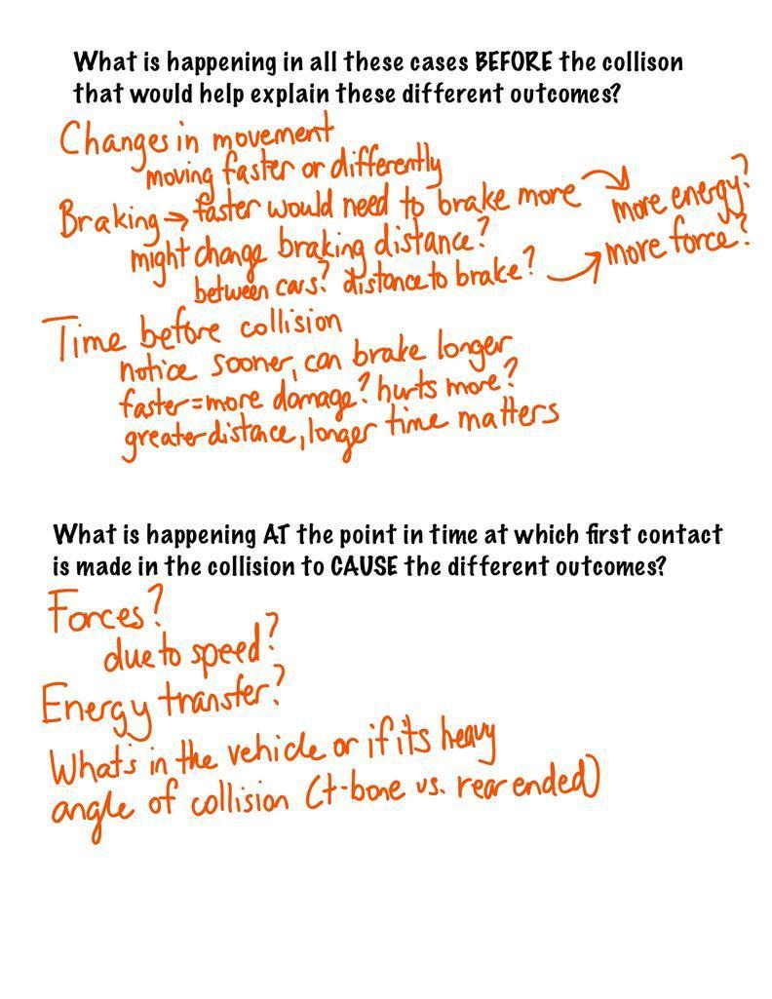  Give a half minute to consider the 4 cases. Ask students if there are any additional cases we need to add to represent that are not represented already. If any new cases are suggested and the class agrees that the 4 already made ones don’t capture that 5th or 6th case, then make another setup using two more cars, and a piece of paper to label the setup. Move on to capturing ideas that students discussed on a poster paper. Guide students to consider what factors might influence the severity of the crash, starting with what happens before the collision first.  Say, We not only played out the scenarios with the crash, but as I was walking around I noticed that you were also making changes to the cars before the crash. What changes were you making before the crash that were different between distracted versus non-distracted conditions in the system that might help explain why we have different outcomes?  Begin a consensus discussion by focusing on what is happening before the collision on Chart 1. Lead a discussion to determine that factors such as speed or distracted driving and distance from impact could play a role in the severity of a collision. As students share, add their ideas to the first chart titled, What is happening in all these cases BEFORE the collisions that would help explain these different outcomes. Example prompts and responses are below:  Suggested prompt Sample student response  What did you say might be happening in all the cases shown (A-D) that would help explain WHY there would be different outcomes? There is at least one distracted driver vs. there are none. The vehicles would be traveling at different speeds when they collide for distracted vs. non-distracted driving. The non-distracted driver braked sooner.  Why might distracted driving affect the speed the vehicles would be traveling when they collide? It would affect how much the vehicles brake before colliding. There would more braking in non-distracted driving then distracted (where there might be none at all  When you say braking longer, do you mean distance? Time? Maybe both?  But what impact would braking distance or time actually have on the cars as they are colliding? What impact would that have on the vehicles as they are colliding? Maybe the higher the speed, the more force in the collision? If they don’t have as much time to break there is more energy in the system  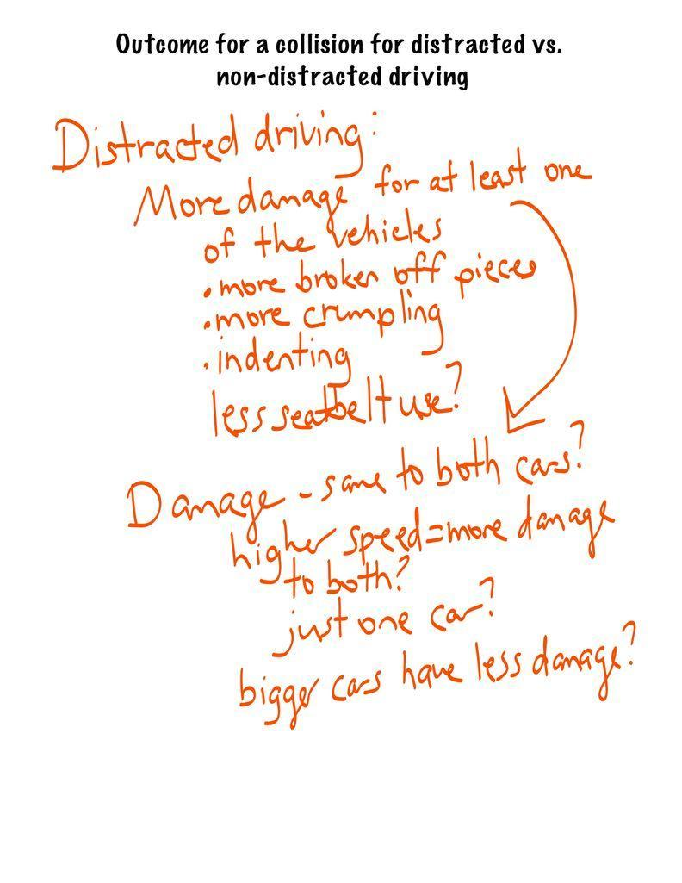  When students start to discuss time, push students to explain what distances or times the class is referring to, if they are referring to distance to a fixed point in space, or a distance to between the vehicles. Determine if the class is also referring to time at which something starts happening or the duration (length of time) something happens. Record any ideas that come up on the first chart titled, What is happening in all these cases before the collision, that would help explain these different outcomes. Most students are likely to have competing ideas regarding frame of reference, so mark these with question marks.  Shift to the bottom prompt on the same chart, asking about what is actually happening during the collision that may cause different outcomes at the point in time at which first contact is made in the system, beyond just saying differences in speed. Students are likely to bring up speed, vehicle differences such as weight, and angle. Record any ideas students may have on the bottom of the chart under the header, What is happening AT the point in time at which first contact is made in the collision to CAUSE the different outcomes.  Move to Chart 2 (Impact on the Vehicle). Say, It seems that we all think there are factors that might affect the outcome of the collision that come into play before the collision even occurs, but we also think that distracted driving might have something to do with this. What might be different in a collision with a distracted driver vs. a non-distracted driver collision?  Lead a discussion to determine these differences and record them on the second piece of chart paper. Students are likely to focus and talk about what they will see differently from the more distracted perspective (more damage, etc.) and this is fine. Ask students to clarify the differences in distracted and non-distracted if they only mention more severe or outcomes of only one condition. Document the differences in each example and ask students if one car would be damaged more than the other. Example prompts and responses are below.  Suggested prompt Sample student response  What might be different in a collision that had distracted drivers versus no distracted drivers? Maybe the speed- if you’re distracted you might be going faster. They might break at different times, which could make the distracted collision worse. There might be more injuries in the distracted condition.  Is there anything that would be visibly different between the two vehicles in these two cases? The crash would just look worse in the distracted case, like there might be more broken parts, while the non-distracted case might not be as broken. The cars might look shorter after the distracted case, and the non distracted driver scenario might have less visible impact or be longer because its not as smashed.  We’re talking about damage between a distracted and non-distracted case. If a distracted driver collided with a non-distracted driver, do we think that the damage would be the same on each car, or the distracted car would look worse? They’re both colliding, so it might be the same? I’m not sure…. Accept all responses.  Shift focus to Chart 3 (Outcomes for People in the Car). Say, Now that we have thought about the outcomes of the vehicle, let’s think about the occupants.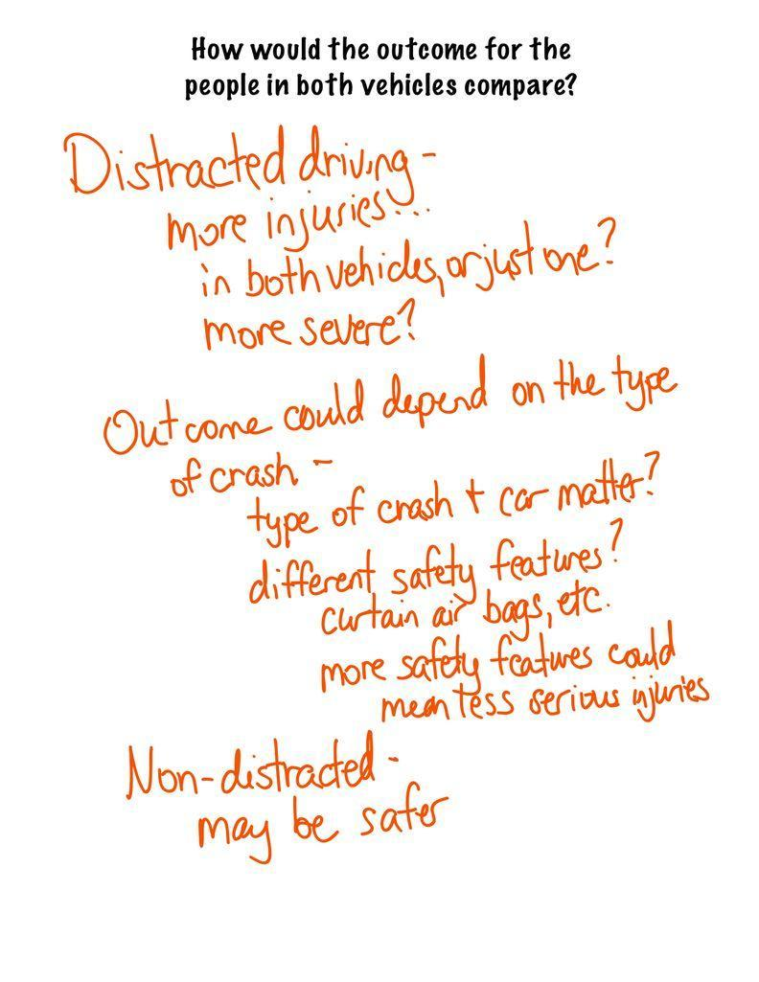  Remind students that the number of deaths is still steadily decreasing over time, but the number of crashes has increased, and our number of injuries has also moderately increased. Ask students to speculate about what differences in injuries we might see in a distracted versus non-distracted collision, and what might cause those differences. Record these ideas under a new heading or on a separate chart titled, How would the outcome for the people in both vehicles compare? Example prompts and responses are below.  Suggested prompt Sample student response  How would the outcome of the people in both collisions compare? The distracted case might have more injuries than the non-distracted case.  Would the outcomes be the same or different for the people in each car in a collision? Why or why not? They might be different because of the type of car. Older cars are stronger, so if it’s an older car it might protect the person more. The person may be closer to the center of the accident if they are in a smaller car. If a smaller car gets hit by a larger car, the person in the smaller car might get hurt more. It depends on the type of collision, like a t-bone would have different injuries in each car.  Why would the injuries in a distracted case be different from a non-distracted case? The car might be hit harder or at a different angle. There might be more smashing in the vehicles that are distracted, so they might be closer to the center of the crash. If you’re constantly distracted, you may not be wearing your seatbelt.  Emphasize that this feels like a set of additional things we should be trying to explain could be affecting the outcome of the collision and suggest we revisit the list of these factors/features in the system we generated earlier and add to these.  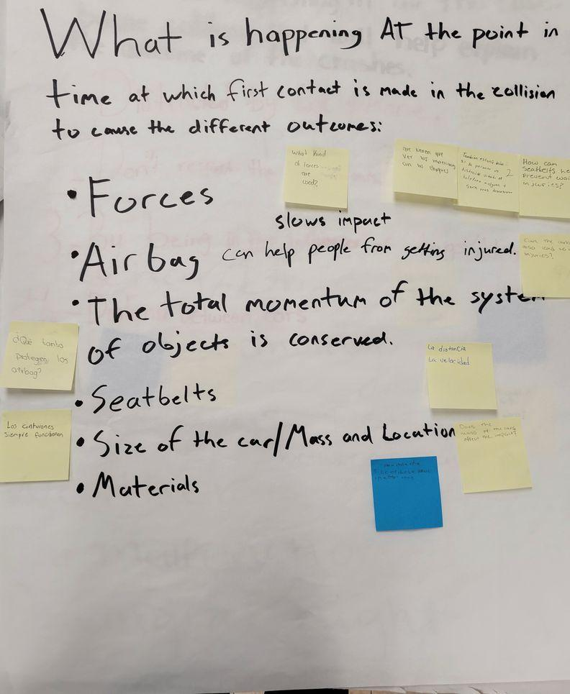  Develop initial questions for the DQB. Display slide M. Read the text at the top of the slide. Point students to the Distracted Driving Initial Consensus Model charts and then say, On a sticky note, record any new questions this model raised for you. Record only one question per sticky please, and don’t forget to add your initials so that we know who contributed a question when we share out later.  Instruct students to place their sticky note next to any phrase on the three charts that most applies to their question. Tell students that we will come back to these questions next class period.  ASSESSMENT OPPORTUNITY What to look/listen for in the moment: Look for students to: - develop questions about outcomes for a distracted versus non-distracted driving collision. (SEP: 1.1) - ask questions about the effects of changes in mass and velocity (DCI PS2.A), among other variables, on the outcomes of a collision (note that students will likely not use the appropriate scientific terminology at this point, and that is fine). (CCC: 2.1) What to do: As students are drafting their questions, circulate to ensure that students are including one of their potential variables on at least one of their questions. If students ask a question that inherently references or utilizes the mass or velocity of the object, ask students to consider if the variable is causing or is just correlated to the potential outcomes in a distracted vs. non-distracted collision. Since this is the initial development of questions, students should be unsure about these connections, this is fine. Over the course of the unit, students will work to further develop their ideas regarding momentum and its effect on collisions. Building towards 1.A Ask questions that arise from careful analysis of data about correlations between vehicle collisions over time and changes within and outside of the vehicle-driver system such as driver distraction, vehicle mass, and vehicle velocity that can only be answered using empirical evidence. (SEP: 1.1; CCC 2.1; DCI: PS2.A)  Revisit (and add to) a list of other factors. Display slide N. Refer students to the factors the class had listed on the Trends chart and ask students which of these factors we have worked to explain. Students will say distracted driving. Suggest that now that we have captured a record of our ideas about how distracted might affect the outcome of the collision, we should also try to explain how some other factors might affect the outcome as well.  Emphasize the trends described at the top of slide N: We know that crashes have increased in more recent years, BUT injuries and deaths of people in the vehicle have decreased. Suggest that we develop two different lists of possible factors that could contribute to each part of this trend.  Ask students to revisit the Distracted Driving Initial Consensus Model charts. Record any additional suggestion of important factors that should be added to the list to explain this trend that they may have come up with since the last time the chart was created. Record any additional ideas students share for each.  Ask students to identify which of these factors are different from distracted driving, in that, they influence the outcome of the collision, but are mostly independent of how people are interacting to and/or responding to what is happening around them. Put a checkmark next to each of these. These will tend to include the physical attributes and structures in the system such as:  - Size or weight of the vehicle(s)  - The type of road or road conditions  - Angle of impact  - Age of vehicle  - Seatbelts  - Airbags  - Lane assist, automatic emergency braking, or another adaptive technology  - Materials the vehicle is made of (e.g. Plastic vs. metal)  - Shape of the vehicle or type of vehicle (truck vs. car) | ✱ STRATEGIES FOR THIS INITIAL IDEAS DISCUSSION  During the initial consensus model discussion, students may have varying ideas on what contributes to the severity of a collision. As students share, areas of disagreement or uncertainty may emerge. If this happens, honor those student ideas by recording them on the current chart and create a convention, such as a question mark, to show that the class is uncertain about the factor or idea. While this strategy is mentioned in the first chart creation below, it is a strategy that can be used across multiple consensus charts and models in this lesson.

9 · DEVELOP AN INITIAL MODEL FOR FACTORS AND FEATURES | 7 min
MATERIALS: Other Factors/Features
Develop an Initial Model. Point out that the list we developed identified possible variables that could cause these increased injury outcomes, and that the check marks indicate some factors or features that are related to a physical attribute or structure of something in the system. Emphasize that to understand all of the trends in the data, as well as start considering ways to make design safer vehicle transportation systems, we will need to consider some of these checked factors or features beyond just simply saying they may be a possible cause. We need to try to understand how or why any one of those variables would cause a decrease in deaths and injuries of people in the vehicle in recent years, even though the number of crashes has increased.

Show slide O. Distribute Other Factors/Features and ask students to select one of the checked variables on the list that they want to try to explain. Tell students that we want to explain how or why that factor or variable would contribute to this trend in the data we saw (a decrease in deaths and injuries of people in the vehicle in recent years).

Before allowing students to begin, take a quick poll of how many students are picking a given factor. If you find nearly all students are picking just two factors (e.g. seat belts and airbags), ask for some volunteers who’d be willing to try explaining a different factor to ensure a wide range of explanatory ideas.

ASSESSMENT OPPORTUNITY | What to look/listen for in the moment: Look for students to:  - identify and model safety features designed to change the physics of a vehicle collision (do not expect students to be able to explain how these features affect the collision yet) (CCC: 2.3)  - use ideas about motion, size, speed or forces to make connections between the safety features they model and specific trends that they see in the graphs (making a prediction). (SEP: 2.6; DCI: PS2.A)  What to do: As students work on their models, circulate and ask questions such as these:  - How does this factor or feature work together with the overall car system?  - What effects does this have on the outcome of the collision?  - How is this factor or feature’s function causing or is correlated to that outcome of the collision?  - What evidence would we need to figure out more about the function of this system component?  Building towards 1.B Develop a model of a vehicle-driver system that includes safety components designed to alter the physics of a collision in order to predict the impact these components have on traffic safety statistics. (SEP: 2.6; CCC 2.3; PS2.A)

In preparation for the home learning assignment, take a high resolution photograph of the first consensus model chart. Be prepared to share the image with students at the end of the day.

10 · CONSTRUCT THE FACTORS AND FEATURES INITIAL CONSENSUS MODEL | 18 min
MATERIALS: Other Factors/Features, Chart paper, markers
Create the Factors and Features Initial Consensus Model. Display slide P. Gather in a Scientists Circle to develop a record of what we agree on and where we have competing ideas for different factors that start affecting the outcome of the collision at different points in time. Ask students to bring their copy of Other Factors/Features.

Say, We have a lot of factors and features represented by our class, but do they all work the same way and at the same time?

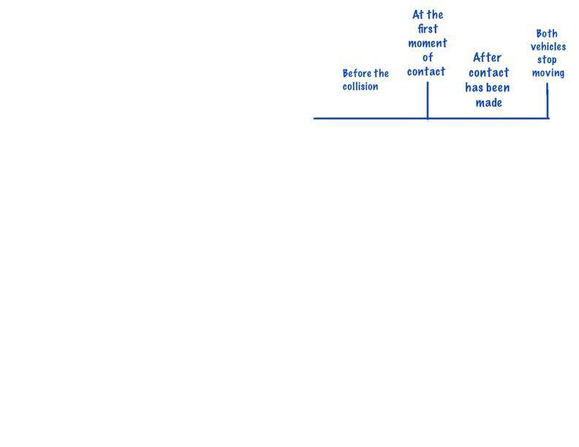
Students should answer that they do not work the same way or at the same time. Ask students to explain when these factors and features might have an impact on the collision. Students should say that some features work before the collision, like wheels and braking, and others work during the collision, like the frame of the car or seatbelts. Draw on the chart paper the time series in question. Break up the time series into 3 moments: before the collision, the moment that the objects make contact, and during the collision.

Share and record factors and features and effects of those factors and features. Add a poster to the left or right of the time series poster. Ask students to share a factor or feature that they have modeled. For example, students may mention airbags. Draw a diagram of this feature in a space around the time series and ask students to explain how this feature works. Allow students to explain their ideas and record student ideas around this feature. Press students to explain what this feature does to reduce the number of injuries and how this affects forces in a collision. As students present their ideas, list them around the item being modeled. Put a question mark next to ideas that the class is not in consensus about, and stars or exclamation points next to ideas we can all agree upon. Ask students to then explain when this factor/feature begins to affect the outcome of the collision, at timepoint 1, 2, or 3. Accept student responses and label the item being drawn with 1, 2, or 3.

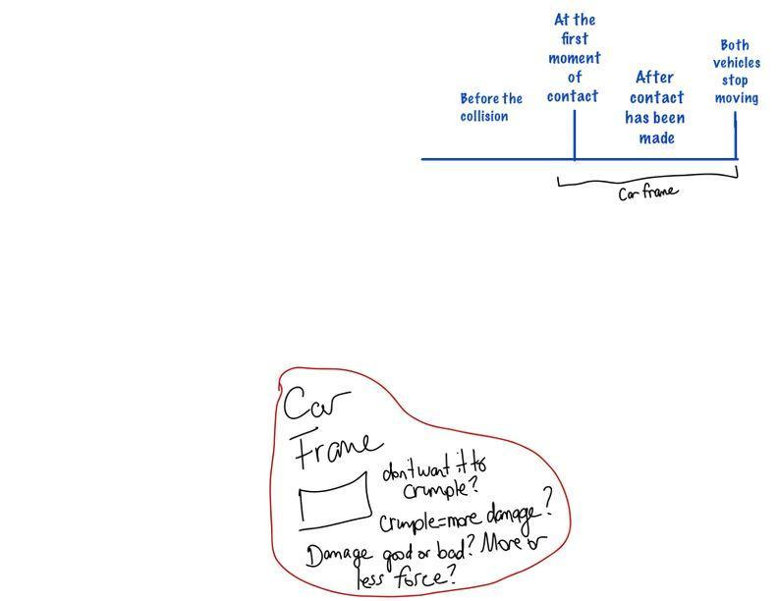
Apply the factor to the time series. Move to the representation of timepoints 1, 2, and 3 on the first poster. Ask students to explain during which windows of time the factor or feature would affect the outcome of the collision. Draw a bracket under the moments in time that students believe applies to that factor or feature and label it with the name of the factor or feature. If students do not agree on a section of the time series, do not bracket that area. Instead use a dotted line to represent this area as an area of question amongst the class.

Add more factors and features to the model. After applying the first item to the timeseries, move on to another factor or feature. Repeat this process until all factors and features are present on the model. Below is a list of factors and features that students may mention, organized by where students may believe they impact the outcome of the collision.
- In time series A, before the first moment of contact between the vehicles.
- Brakes
- Wheel size / conditions
- Road conditions
- Automatic braking
- Seatbelts (potentially)
- In time series B, at the first moment of contact between the vehicles
- What the vehicle(s) are made of
- The size/mass of the vehicle
- The angle /point of contact between the vehicles
- Air bags
- Seatbelts
- In time series C, after the first moment of contact between the vehicles
- Air bags
- Seatbelts
- What the rest of the inside of the vehicle is made of (steering wheel, dashboard, seats in back)

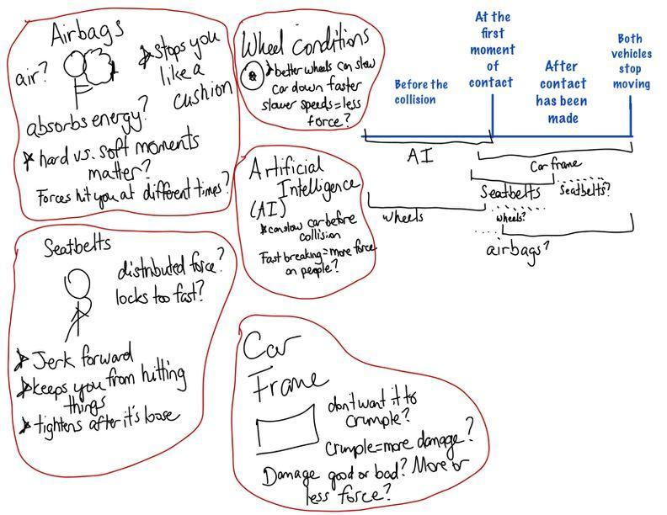
After all factors and features have been shared, take a moment to look back at the models. Ask students what seems similar and what seems different about the factors and features we have modeled. Allow students to quickly share out their ideas, and accept all responses. Explain that tomorrow we will continue to think about what might be contributing to the increase in crashes and injuries, and what additional questions they may have.

End of day 2
11 · REVISIT MODEL AND WRITE DQB QUESTIONS | 3 min
MATERIALS: Other Factors/Features, sticky notes, markers, Factors and Features Initial Consensus Model, Distracted Driving Initial Consensus Model
Review the consensus model. Display slide Q. Give students a moment to reflect on the Factors and Features Initial Consensus Model from last class, and discuss with a partner what they find similar or different in their Other Factors/Features and the second initial consensus model. This will help students re-familiarize themselves with the model. If you are ahead of schedule and this step is done on the same day that the second consensus model is built, skip the slide R instructions and proceed on to slide S.

Bring the class back together and display slide R. Remind students that over the past two days, the class has worked together to create two initial consensus models. Both of these models represent what we think might be contributing to the trends that we see on our graphs showing crashes and injuries over time. Remind students that we have also encountered questions as the models were constructed. Now students will get the opportunity to consider their questions again.

Read the text at the top of the slide and direct students to write at least one question they have on a sticky note. Point out that each sticky note should contain only one question, and students need to write their initials on the back of the sticky note. Tell students that it is okay if most of their new questions relate to the Factors and Features Initial Consensus Model, since questions related to distracted versus non-distracted driving may have been posted earlier on the Distracted Driving Initial Consensus Model. Also let students know that it is okay to add any new questions they also have about distracted driving at this time. Remind students that the DQB will grow over the course of the unit, and that when the class thinks about new ideas or looks at data in a new way there will naturally be more questions that will emerge in that process.

ASSESSMENT OPPORTUNITY | What to look/listen for in the moment: What to look/listen for in the moment: Look for students to:  - ask questions about the effects of changes in mass and velocity (DCI PS2.A), among other variables, on the outcomes of a collision (note that students will likely not use the appropriate scientific terminology at this point, and that is fine). (SEP: 1.1; CCC: 2.1)  What to do: As students write their questions, circulate and verify with students that their questions can be answered with observations or investigations that can be done within the scope of the classroom, and are related to the components of the system. Ask questions such as:  - What can we do to figure out the answer to your question? Can this be done within our classroom with data or evidence from an investigation or simulation?  - What questions do you have about your factor or feature?  - What questions do you have about how the factor or feature relates to the overall system?  - What questions do you have about the effects and function of your factor or feature?  - Do you think your feature or factor causes any changes to the system as it collides with another object, or is it just related to the system?  Building towards 1.A Ask questions that arise from careful analysis of data about correlations between vehicle collisions over time and changes within and outside of the vehicle-driver system such as driver distraction, vehicle mass, and vehicle velocity that can only be answered using empirical evidence. (SEP: 1.1; CCC 2.1; DCI: PS2.A)

12 · Add questions to the DQB | 16 min
MATERIALS: Sticky notes, markers, Factors and Features Initial Consensus Model, Distracted Driving Initial Consensus Model
Support students in building out the rest of the DQB. Present slide S. Arrange students in a scientists circle with the two consensus models positioned so that all students have easy access to the models. Tell students, Let’s use the two initial consensus models that we have made to organize our new questions. We can place questions related to the models on top of the parts that they are associated with on the poster, and then cluster related questions nearby.

Explain to students that they will take the lead on this process. Choose the first volunteer to begin the process and then allow students to follow the process outlined on slide T. Step in when necessary to point students to some of the class’ norms to encourage equitable participation. The student-facing directions for assembling the DQB printed on the slide and the handout are:

- Choose a volunteer to go first, read their question, and put it on the DQB near the part of the system to which it is related.
- Raise your hand if you have a question that is related or the same.
- The first volunteer selects the next student whose hand is raised. The student who is called on reads the related question, says why or how it relates, and then moves it onto the DQB with the original question.
- That student selects the next student who will read another related sticky note and move it, and then call on the next student.
- Continue until the class agrees that all the related questions have been placed, and that they are located in the right place on the consensus model. Then go back to step 1, and choose a volunteer with a different question to start a new cluster. Continue until everyone has shared at least one question.

Allow students to share their questions and moderate the process until all questions have been posted on the consensus models that make up our DQB.

13 · BRAINSTORM RELATED PHENOMENA | 10 min
MATERIALS: Chart paper, markers
Brainstorm related phenomena. Say, We have been thinking primarily about collisions between two cars to this point. Are regular cars all that we have on the road, and do regular 4-door sedans only ever collide with other 4-door sedans?

Use slide T to prompt students to turn and talk about the following:
- What are some other types of vehicle collisions that we should learn more about?
- What else could a cars collide with that we should investigate to improve everyone’s safety?

After 2 minutes, bring students together to share out their ideas. Keep a public record of students’ suggestions in response to the second question at the front of the room. Title the list: “Related Phenomena.” You can do this on chart paper, a white board, a projected document, or a transparency. You may hear ideas such as:
- Cars colliding with walls
- Larger vehicles colliding with smaller vehicles
- Collisions between vehicles and wildlife
- Collisions between vehicles and pedestrians or bicyclists

After this, ask students if they have any more questions that they would like to add to the DQB. Allow students to read the questions and quickly add any questions they have to relevant areas of the DQB.

14 · DEVELOP IDEAS FOR INVESTIGATION AND DATA WE MIGHT NEED | 16 min
MATERIALS: Strips of 8.5x11 paper, tape, markers, Trend lines chart, Ideas for Investigations and Data We Might Need chart
Say, There are a lot of collisions we feel that we need to learn more about to improve the safety of those humans and other living things involved. If we think back to our trend lines, it seems like we can connect some of these ideas, and ideas from our models, that might help explain these trends. Let’s think about that now.

Compare models to trend lines. Use slide U to prompt students to turn and talk about the following: How do our models explain our trend lines? Remember that this is an initial ideas discussion designed to surface student ideas for investigations, and do not expect strong connections right now between science ideas and trends in the data.

After 2 minutes, bring students together to share out their ideas. Direct students to look back at the graphs on which we had drawn trend lines and labeled potential causes. Guide students to point out that the first models the class developed might apply to the areas we have flagged for distracted driving, while our new model applies to the decreases in crashes and injuries.

Point out that in order to explain these trends and to understand why driving has become less injurious over time even though crashes have increased, we will have to investigate the questions we have developed over both models.

Ideas for investigation. Display slide V. Ask students to get into small groups and review the clusters. Clusters may have emerged by either poster or sections of posters. Mark these sections clearly for students. Have students consider each question cluster and try to develop an idea for investigation centered around that clustering. Assign different groups to start with a different topic cluster.

When students have determined an idea for investigation, ask students to write their idea down on a strip of paper. Emphasize that their group can then stick their strip of paper to the chart you are going to create and come up with a second idea, or they can move on to a new topic cluster.

As students develop questions, display the Ideas for Investigations and Data we Might Need chart. Quickly write each cluster title with an area under each cluster title for students to add strips of paper. Make sure that tape is handy for students to easily post their ideas to the chart.

Give students 6 minutes to record their new questions on paper strips and add to the corresponding topic cluster on the chart. At the end of this time all student groups will have needed to add their strips of paper to the Ideas for Future Investigations and Data we Might Need chart.

After the questions have been generated and posted, review each cluster with students for common ideas for investigations or data requests. Anticipated responses are below:
- Reaction time, distance, and vehicle speed measurements.
- Video or photos of collision
- Collision statistics data by vehicle type
- Crash dummy measurements (motion, forces, damage)
- Testing various vehicle collision conditions ourselves in a scaled down system (e.g. two vehicles on a track, with different speeds, masses)
- Testing different type of vehicle materials ourselves and the effect on the collision in a scaled down system (e.g. metal, plastic, other)
- Testing the effects of adding seat belts, airbags, etc… on the damage to a simulated passenger in the vehicle (e.g. an egg, a clay ball, etc…)
- Use a computer simulation to test the effects of different design solutions (seatbelts, airbags, etc…) on the people and the vehicle.

Say, It seems like we have a lot of ideas for investigation and have identified data that we need. Let’s look back at our two charts and consider where to start.

Ask students to consider what area we seemed to think contributed the most to our trends in data that we should investigate first. Students should identify that they think the trends identified in the graphs were related to distracted driving. If students do not directly go to distracted driving, revisit the list of potential causes under each segment of the graph and remind students that their first set of ideas focused around the impact of distracted drivers on the data. Explain that since the class believes that this is the most likely potential cause of the increase in crashes, we will start there next class.

